Mohammed Karim Seck

1303551

Assignment 2 Unit 28  
  
Choc o Lat website

Designs

Contents

User Requirements 2

Client Needs 2

End User Needs 3

Design Documentation 4

Planning 9

Initial plan of ideas 9

Navigation map 11

Mood board 11

House Style/Colour scheme 12

Top navigation 12

Shapes 12

Colour 13

Frames, tables, block level and inline containers 13

Interactive features 13

Meta-tagging 13

The mark-up, CSS and client side scripting languages to be used in the construction of the site 14

Client Side HTML tags 14

CSS tags 16

Box Model 17

Positioning and spacing 17

Styles for headings 17

Lists for horizontal navigation and vertical navigation 18

Links and pseudo classes setting pseudo class order 19

Pseudocode and Flowcharts for JavaScript Features 19

Tools & Techniques 19

Aiding User Access 25

# User Requirements

## Client Needs

* + 1. **Timescale:** The timescale is actually the main end for the time that I have got for the assignment, in designing which is on 25 of October 2019, making which is the next month on 21 November and texting that is like the making one on the next month.
    2. **Costs:** I did not had any extra cost on making my website and elaborate it by launching into the browser which it was free and reliable to do it, by talking about making I had no cost for use atom as a programme and build the main code.
    3. **Image that the client wants to portray**: The main portray pictures that client want to see are all of them like the website layout of a high quality that represent those picture, as all of them have got a high definition when viewed.
    4. **Level of security both now and in the future:** As a secure website maker I am pretty sure and secure to say that the user will not get any kind of issue on navigate into the website, as the website have got the most recent high protection for a software. Like when they will log in they will make their own account with password and recognize word before create the account. In future in case of malicious hacking your account will be crushed with your details and you will get a response which it say ability to create a new account or progress with a new account by entering the same email with a different password.
    5. **Support needs:** Most of the support that my website can offer are suitable for the costumer problem like for a log in or buy an item. The software of the website it will immediately sort that out and email the website maker.
    6. **Maintenance**: The maintenance support the costumer issue and the upgrade for the website with new layout and design that accomplish the taste of the costumer.
    7. **Search Engine Visibility:** The main search engine instead of only show what you want or what you are looking for, it sustain your taste into the main page by upgrading the main design for the guest

## End User Needs

* + 1. **Sound:** The website does not provide any kind of sound, if not only from the video which they show representation of making or extra detail of a product. The sound like in other website could variable and it has a good quality when listened.
    2. **Static and Dynamic Graphical Representation:** The static represent the images and the pictures implemented by java script programme where you can identifies the main features as width and length.
    3. **Navigation:** The navigation item are all okay and are indeed to be used like the top navigation bar which it connect it with extra pages or some internal page that are connected each other.
    4. **Delivery of content with appropriate use of language/format etc..**: The content it should be arrive at next 3 days as the website it support with some extra features like biscuit or tea to best enjoy the moment and the taste. The language is formal and reliable to any gender and age.

# Design Documentation

|  |  |
| --- | --- |
| **Website Design Home Page** | **Content outline** (**Description)** |
|  | **In the “Home page” first slide I have implemented the main features that my design was needed to create the website as the: shapes, the text and the pictures; all attached into a brown background that reminds a mix of dark and milk chocolate.** |
|  | **In the second slide I have used the same format as the first one, with some shapes and different pictures that have searched and download from Google.** |
|  | **In the third slide I have added six shape with the same measure as I have needed to describe the context and have a description of the picture added for the discount offer.** |
|  | **In the last slide of the Home page with the classic brown chocolate background I have enlarge a shape and added five pictures which they figure out a sequences for the flavour and interest of the guest. And more added are the four picture which they are the main social media for the website and the contact details aside of them.** |

|  |  |
| --- | --- |
| **Website Design Special page** | **Content outline** (**Description)** |
|  | **In the special page I did not have implemented the same background colur as the Home page, as this time I have choose an lightful colour which I believed is more adatted for the costumer visitor.** |
|  | **On this page is actually added only a You tube link for the real website that describe the main step for a chocolate flavour.** |
|  | **This slide is showing a shape occasion that gives a briefly description for the discount item. In the page there are just the shapes with the text and the pictures.** |
|  | **In this special slide I have added differently shapes as they where needed to represent a slideshow as it is called into the design page. The features added are text for the picture which are the prize of the webpage.** |
|  | **The last page is actually equal to the previous one which they have got the same features and they represent the same stuff for the website.** |

|  |  |
| --- | --- |
| **Website Design Account page** | **Content outline** (**Description)** |
|  | **In the special page I did not have implemented the same background colur as the Home page, as this time I have choose an lightful colour which I believed is more adatted for the costumer visitor.** |
|  | **The second slide of the Account page represent a payment method with shapes and a picture t5hat is bigger than usual.** |
|  | **The third slide is just a repayment for the guest that just visit our website where it say thank you for be with us inside another big picture taken from Pexels** |
|  | **On the fourth slide there are a lot of shapes and a picture that take the place of the guest photo and attached on it there are the shapes with the personal details method** |
|  | **The last page is actually equal to the previous one which they have got the same features and they represent the same stuff for the website.** |

|  |  |
| --- | --- |
| **Website Design Order page** | **Content outline** (**Description)** |
|  | **In the special page I did not have implemented the same background colur as the Home page, as this time I have choose an lightful colour which I believed is more adatted for the costumer visitor.** |
|  | **The second slide of the Order webpage is a little of bit more complicated as it takes more slideshow together to show different products and identification the type of products, and close to them there are the button that give to the user to select an item.** |
|  | **The fourth slide that I have designed is format by shapes and picture which they are needed to describe the order type for the costumer as for the start of is product, the progress and the discount application.** |
|  | **The last page is actually equal to the previous one which they have got the same features and they represent the same stuff for the website.** |

|  |  |
| --- | --- |
| **Website Design Review page** | **Content outline** (**Description)** |
|  | **In the special page I did not have implemented the same background colur as the Home page, as this time I have choose an lightful colour which I believed is more adatted for the costumer visitor. The on;ly careful difference is the title of the page which is related to the second slide.** |
|  | **The second slide represent multiple pictures attached each other which I have learned from w3 schools to accomplish a type of background pictures for that margins** |
|  | **The third slide represent two red shapes and some text which they describe some benefits for the guest that has finished to overview our website.** |
|  | **The fourth slide is a representation of the comments and review of our website with a special benefits of how to make a good chocolate for everyone by seeing the link implemented.** |
|  | **The last page is actually equal to the previous one which they have got the same features and they represent the same stuff for the website.** |

# Planning

## Initial plan of ideas

The initial ideas for the website where supposed to be professional and respond into a professional website like for a good work. I thought I must provide a good website and show it with all the details needed, as all the ideas and opinion that I have got from my teacher. I have been able to construct the right design which it is the most suitable for me and that it looks good and reliable for the clients.

Most of the ideas that I have got and I have used into the website are:

**Shapes:** I have used the shapes to implements pictures which they comes from W3schools as the link is provided: <https://www.w3schools.com/howto/tryit.asp?filename=tryhow_css_shapes_oval,those> shapes can get different kind of details which I have particular used for my website as the size, the colours or the radios in special case as oval and parallelogram, I have most used the parallelogram for the title of the webpage as Discount and Choc O Lat as it is the main name for the webpage. Most of the shapes that I have used are circle and oval for pictures which from my view they looks better.

**Slideshow:** The slideshow are a programme code that are used to show multiple pictures which they are really fashion and reliable to view in case of a presentation or a list combined with the element that you have choose. In my website I have use different times that codes to make a good look for the website and reduce the space into the webpage.

**Picture from Pexels**: All the pictures that are available to see into the website as the shaded background image, have been downloaded and renamed into the assets folder. And below there is the main folder which is containing all the pictures. I got those pictures from a specific web programme called Pixel which it most satisfy me in case of picture fashion and demonstration.

**Text:** Into the website I have used in multiple occasion the text for a description or to name a thing, I have used different size for the text and sometimes I have even used a different style for it which is the most important part I guess…. As a costumer will future be comforted from see the style of the website? The only thing that I did not implemented into the website is the colour text which I think it was not necessary.

**Align:** The align is the most and easily point that I haver used fir the shapes, the text and most of the picture, as they were need to look exactly like the design so they will not get any issue of be attached all together. I have used the align code as long as the shape code for that case, for the text one I have add hem into the text code in the end. I have even did the same thing for the picture images.

|  |  |
| --- | --- |
| **Column:** I have particularly use the column into all the webpages to a side all the stuff with a perfect order and performance of understanding content. As you can see below it is actually well displayed the measure of the page for the content from 0 to 12 in order to divide the column for the webpages and them stuffs**.** |  |

Like I have previously explained the webpages come to be divided into this measure**.**

**Button:** On my website I have actually added some button which half of them brings to nowhere, as I fought to implement them to fashion the webpage. The other half of those buttons they are connected to other webpages which are the common social media that show a login pages like in the example below**.**

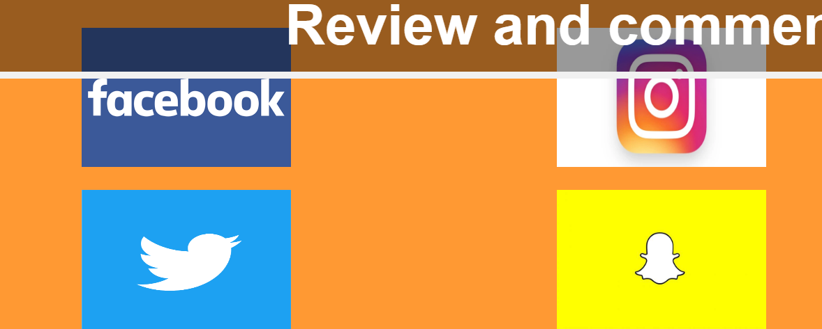

|  |  |
| --- | --- |
|  |  |
|  |  |

**Navigation Bar:** The navigation bar is one of the most easily stuff that I have start to create into the webpage, by using w3school for all the item. I just had need to change the name of the text, the hyperlink and the colour for it which they took me a few seconds. Another change that I have made is the align for the words which they normally are placed in the left side and I move on into the right one as in the design.

## Navigation map

## Mood board

The main mood board that I have used to design and collect all the information’s and details needed was PowerPoint which is the main board for all my design, I have used also the shapes provided to make a kind of style and added the you tube video link instead of a video picture.

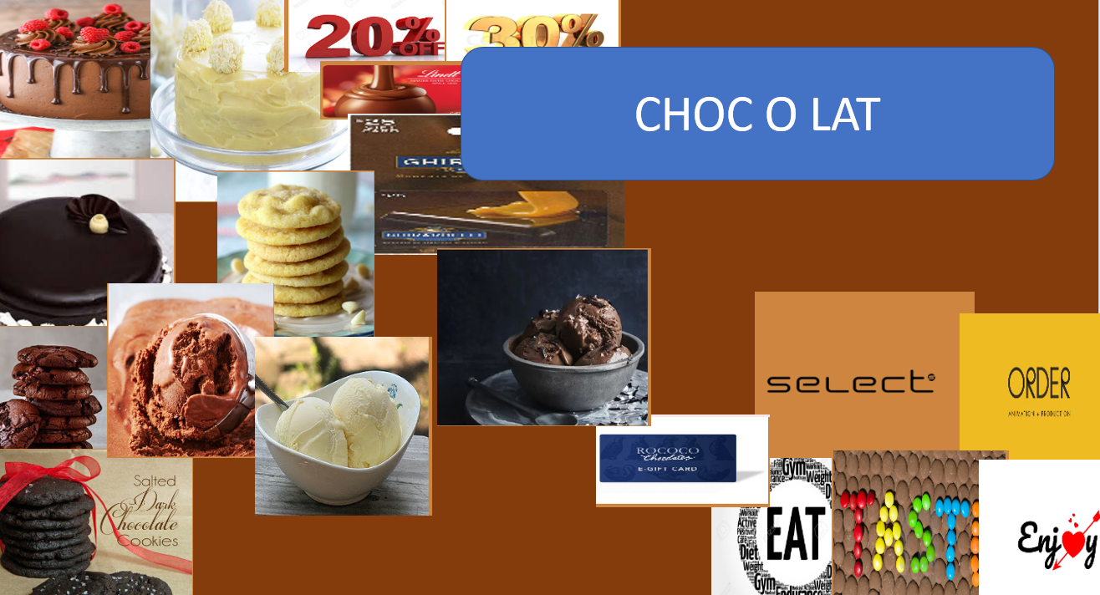

## House Style/Colour scheme

The main colour scheme that I have used into the design to the website are particularly different and they have been placed for an exactly purpose of interest and describe as for the shapes which they are blue in the design, and in the webpage they are red.

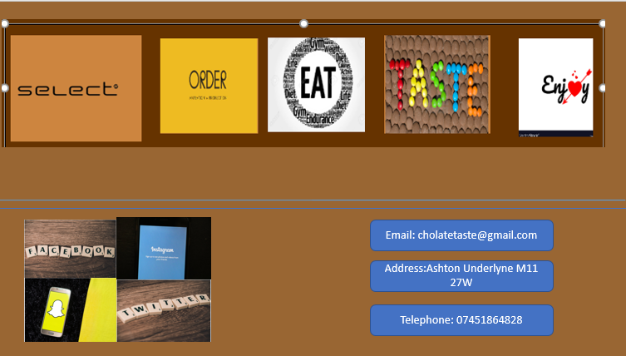

For the background I have implemented a sort of dark chocolate in the design which it was only a practise for build the real website, as in the real there is a colour more light instead of the background in the design, which I believe it is more attractive and it makes remember more chocolate from the view of a guest.

## Top navigation

I have also added a top navigation as you already know which the button connection to the other webpage. They come to be connected with a hyperlink code that gives a door to the other programme room. Like in the example below.

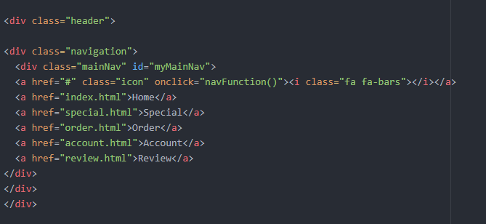

## Shapes

Shapes also that contain text and images, and two of them contains video from you tube. I have fought they might be indeed for a specific topic in a webpage and a better understand of the section included.

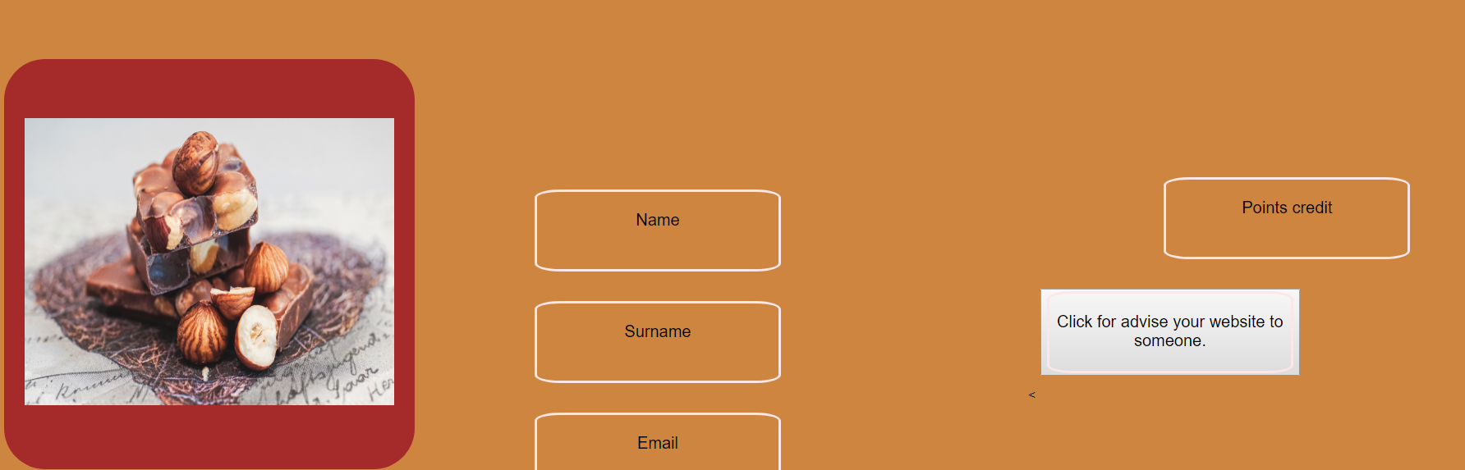

## Colour

The colour are also a topic that gives a better view into the section as for text, images and shapes. The colour are one of powerful elements that make an attraction to the people on the way they refurbished into the website as it makes interest for the eye of a guest. I will say that 20% of the publicity into a website is thanks for the colours.

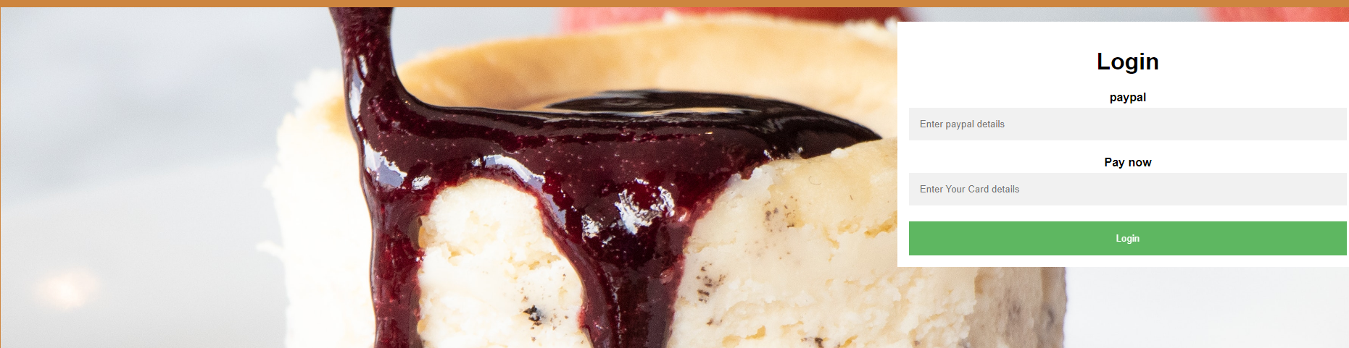

## Frames, tables, block level and inline containers

In this case I have used only the frames which they are the most useful to create a video connection between the web programme and the you tube server. As in the example below I have copy from YouTube, the URL to later change some properties as the final address by placing it with an **embed** code , so it can be possibly understand by the computer and it can elaborate by connecting the two side.



## Interactive features

The main interactive features that you can meet into the website are particular the videos which they are the shortest type of description, the website is even easy to be used by the guest and it did not cause any kind of issue as everything working properly and it not cause any damage for the costumer.

## Meta-tagging

All the meta-tagging have been implemented inside the programme code and later be figured out by the computer.

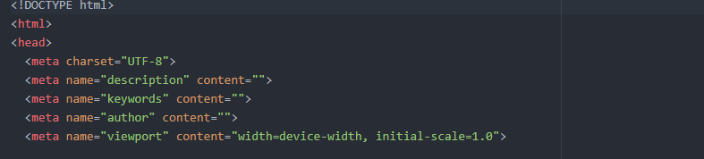

Those are the main Meta tag inside my website codes section they have been implemented to construct the rest of the pages with a specific action.

# The mark-up, CSS and client side scripting languages to be used in the construction of the site

## Client Side HTML tags

|  |  |  |
| --- | --- | --- |
| **Mark-up language** | **Description** | **How it is going to be used.** |
| **<head>** | The header is the main identifier that keeps the main information for the webpage at the top of a programme application, where we actually input tag as: meta, link and style. | In the webpage all the tags that goes at the top of a webpage or they are fundamental to go into the top of the web programme are essential , as when we add them on the top , they are going to work and operate into the webpage and be connected to the other links in the body. |
| **<body>** | The body is the main container for all the tags called embedded that actually cover the main body of a webpage. | By adding embedded stuff that a webpage deserve to put, the webpage is going to operate those instructions, and the embedded tags are paragraph, the div, and etc… |
| **<p>** | As the word say, the main paragraph is the tag where we can add text and add them into the webpage. | By have got the first tag and closing tag we are going to add the text between them and save it, as it appears into a place on the webpage. |
| **<h1>** | The main heading is the main description that identifies the head for the start of a conversation or a paragraph which is normally bigger than the paragraph. | As the paragraph you can add text on it and it will be showed into the webpage with a different size for the text. |
| **<iframe>** | This tag is going to provide a connection between the webpage and the You tube videos server. | In this case you add the URL of the video that you are interested from You tube by changing the last part of the address with the embed definition as it can be recognized by the web programme. |
| **<img>** | The image tag is the main link tag that give the appropriate function for the image link or address as “.png” or pasted from google. | By adding the appropriate address or link, you can add even the height and width and control the size of the picture. |
| **<div>** | The div tag is actually the main dividing tag that divide two side for tags in a web programme**.** | Between the two opening and closing tags you can add all you want and make a space of it in the webpage as it is not going to be attached with the other files. |
| **<br>** | This a tag is a making space property which it adds more space into the webpage and between two tags for the web programme. | By adding this tag between two other tags or in anything, you are going to create some more space for the webpage. |
| **<button>** | The button class tag it the main function that gives the properties to a tag as a real button which it can be connected to a hyperlink if added. | You actually add the opening tag and closing one between the other tags as it going to be attached on what there is inside of it, and making it a button. |
| **<a href>** | The hyperlink is the main operating that activate the link between two web pages or two web programme by creating a door between the two rooms. | By adding the link or the name of the second page it constantly create a connection between them. |
| **<hr>** | This tag is a creating operation for horizontal lines which it show a horizontal line on the webpage with the size and colour you might would like. | By adding this tag between two tags you can actually create a real line on the webpage. |
| **<style>** | The main style guarantee a secure definition for all the other tags that will be added into the body and it create a secure connection | By opening the tag you can actually add all the instructions and tag you need for the body one. |
| **<centre>** | The centre tag is the main specification for occasionally tags where you can add it at the start and at the end**.** | You can add it, at the front and at the end to verify the middle of the tags will belongs to the centre of the webpage. |

## CSS tags

|  |  |  |
| --- | --- | --- |
| **CSS language** | **Description** | **How it is going to be used.** |
| **.mainNav** | This is actually the main tag that represent the top navigation and it respond on the html page. | By adding the tag it is going to respond with the tags on the html and come to be connected together. |
| **.row** | The row is the main representation for a row tag into the web page where other tags will not appear if not included inside | By creating the row with the closing tag, you actually are creating a new line for the web programme where everything outside the row will not occupied the items inside. |
| **.a** | This tag represents a text decoration for any text into the webpage as if they have particular features. | By adding the tag and the definition into the web programme you actually gives the main definition of the tag and on how it is going to work for that decoration. |
| **.header** | The header tag is a representation connected to the html side of the web programme as both they operate for the heading of the webpage. | By using this tag you can actually modify the main contents of the top navigation bar. |
| **.border** | The tag border is going to operate the border for any additional tag as for the navigation bar and other stuff. | By adding this tag you actually modify the components of the navigation bar and make it looks as you want. |
| **.title** | The title tag represents the main explanation for the title into the webpage which is the main heading at the top of a webpage. | You are going to add it into the nav.css programme page and be connected to the other tags into the html page. |

## Box Model

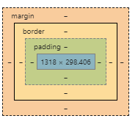

## Positioning and spacing

Applying padding: As you can see from the picture it is represented the main part of the box model as for the padding which is the nearly one to the main content of the website, but in my case I don’t have one.

Margins: That’s actually the same thing even for margins has did not have implemented some of it, as on my website they are not showed any of it, talking about margins which they were the on the side of the webpage and I did not add them because I did not think they were indeed for my website

Borders: Even this time I did not have implement any border that might be accomplish to the main website, those borders in case I was thinking to add them were going to be at the edge of the website.

## Styles for headings

Adding colour: In my website I have added different kind of colour, all of that colour have been taken from colour chart code which is a website that gibes appropriate codes for its colour. The type of colour that I have used for my website are: chocolate: #D2691E, brown: #A52A2A, white and black for the text.

Font size: On my website there are different kind of text size as for the sub tile, the header and the normal text, below there is the screenshot of my text size for each case that I have used it.

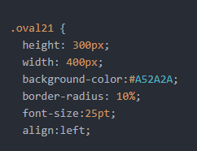 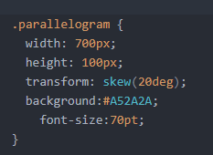 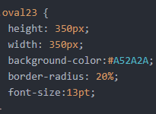 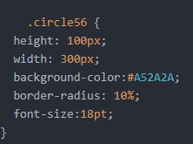

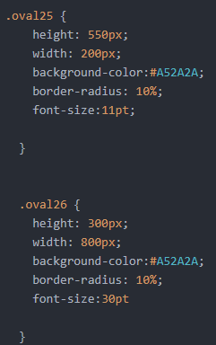 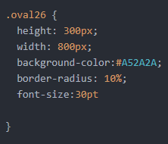

Those pictures above are a representation of all the different font-size text that are into my website.

Font weight: I have added the font-weight for the images which they can modify them features and make them smaller or larger. Like in the example below.

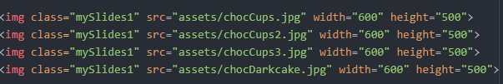

Background image: I did not use any background image for my website as I have used the colour, except for the big pictures which they are implemented from w3schools and they provide the efficient.

## Lists for horizontal navigation and vertical navigation

Applying appropriate styling and a hover effect: In my website I have used the horizontal style effect for my top navigation bar. Below there is the main example for each page as it is equal for any page.

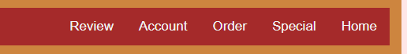

## Links and pseudo classes setting pseudo class order

Adding background images: Talking about background images I have implemented two cases as both of them are in the account page, and they are pictures that have got larger with a method from w3schools.

Applying appropriate styling : All the style have got an appropriate align for them place in case of shapes, pictures of top navigation bar which all three of them can able to be changed depends from whatever you would like to format them.

Removing underlines: I have got some underline into my website which they are called horizontal lines and they provide an essential support as they look like a divider between the two rows of context.

Adding borders: As I have described before, I did not add any border as I did not had the need of it for my website.

# Pseudocode and Flowcharts for JavaScript Features

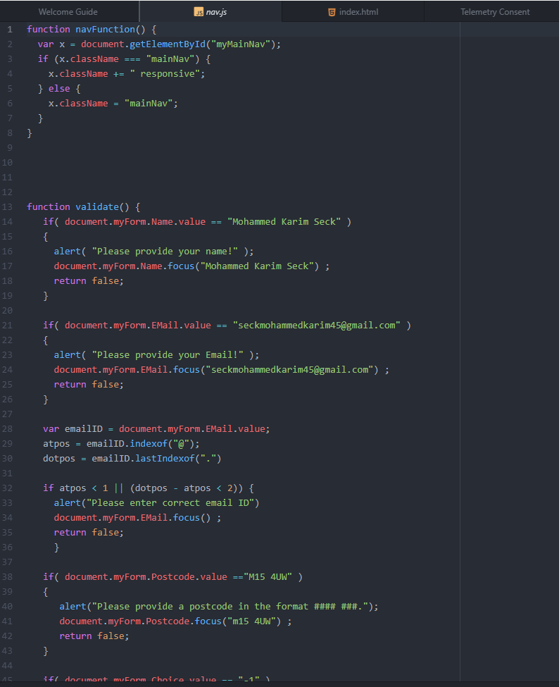

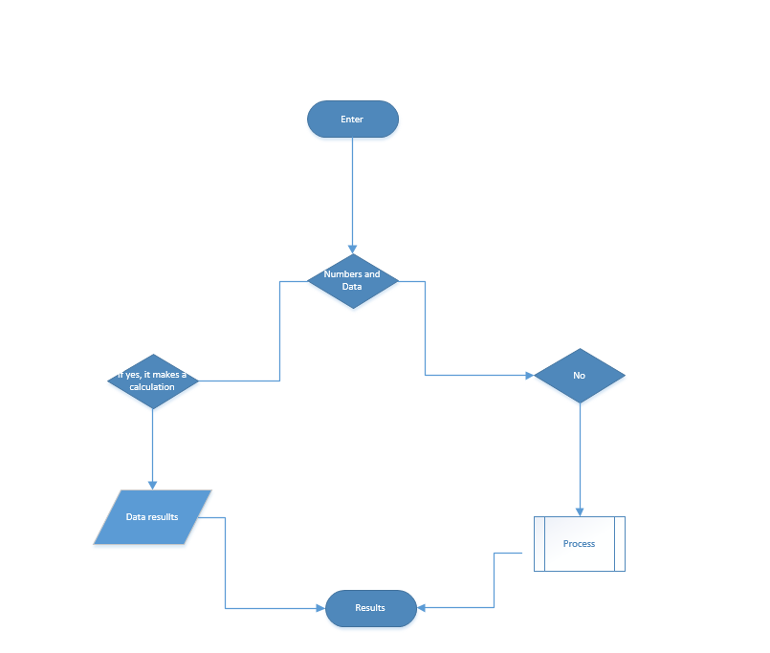

# Tools & Techniques

Before you build your website following your design documentation you need to clearly **explain** the tools and techniques that have been used in the design, specified in ‘**Getting it Down on Paper’**, and construction of your website.

|  |
| --- |
|  |
|  |
|  |
|  |

***In this page as you can see I have clearly used Power point where I have choose the background, from the different choice and options which there is a big variety, and I have used the most adapt one that represents a chocolate website as it’s brown. The second way that I went through were the shapes which I have pick up from the list of shapes as they are really define for an explanation or a presentation. The third way that I went through are the picture which they are a big part for my website and they are essential as a prove for the costumer. The last part that I went through are the lines on the first picture of the home page which they look nice for divide the different parts of a website.***

|  |
| --- |
|  |
|  |
|  |
|  |

***For the second page I have implemented a different background colour as it can look more comfortable for the view of the user. The first difference that you have actually noticed are the lines as I did not add them into the design, but I have add them into the website. The second way that I have choose it was implements the shape and in the first shape I have added the link of you tube as I could not have added all the video. You might be really curious on the page that as the Slideshow, and well on this page being not able to implement the really slideshow, I have put a circle shape and them pictures with a good explanation of each one and in the end I have surnamed it a slideshow on the above.***

|  |
| --- |
|  |
|  |
|  |
|  |
|  |

***In this page I have make some different changes a for the pictures and the container text, The first way that I have changed the picture was by enlarge it and add a shape text that represents the payment method. The second big picture which it look like almost as a background is a way for thanks the costumer making payment and buy from us.***

***The rest of the pages it’s still the same as in the other pages.***

|  |
| --- |
|  |
|  |
|  |
|  |

***This page has got the same features as the previous as I have used shapes to describe text or sow picture that represents the website. On the second slide of the webpage I have added a slideshow as you have noticed which this times they are three and they explain all the type of chocolate that we added. The button on the left side of each slideshow is just a presentation for a selection section like when someone want to add an item to later buy it, he needs to click that button.***

|  |
| --- |
|  |
|  |
|  |
|  |
|  |

***This is the last webpage of the website, and how you have actually noticed immediately I have changes the colour of the spaces from blue to red. And all the six picture which they have been accomplish with the name of the website are implemented into the second slide of the webpage. I have added this method as I think that it was the best solution for demonstrate the efficient of a good website by showing the title on this way.***

|  |  |
| --- | --- |
| ***Atom***  ***In order to construct all my website I have needed to use a web programme to construct all the features deserved which is similar to notepad++, but better and is called Atom. By using Atom I had the chance to implement all the tag and the codes need to build my website and elaborate the features.*** |  |

# Aiding User Access

For the aiding information user access which they referred to the account process access and payment method, being both an important and essential part for the user where he needs to get is item and select them where they can beaded into a reference page that contains id details and information related to him. Below you will see the screenshot of both examples that I am talking about.

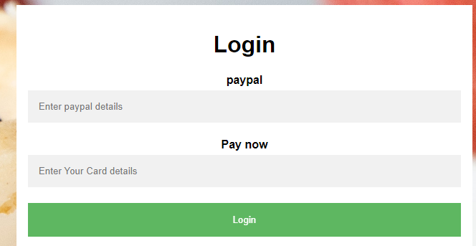

***As you can see by the picture on the right side, the main user aces information needed for the payment method are PayPal like the credit cards details and pay now which it still use the same information and regards for it.***

***In this case for the account access information are represented all the information needed for the website like the Name, the Email, the Surname, which both of them are necessary to create an account for the user as it can later get is item and continue to receive benefits from it.***

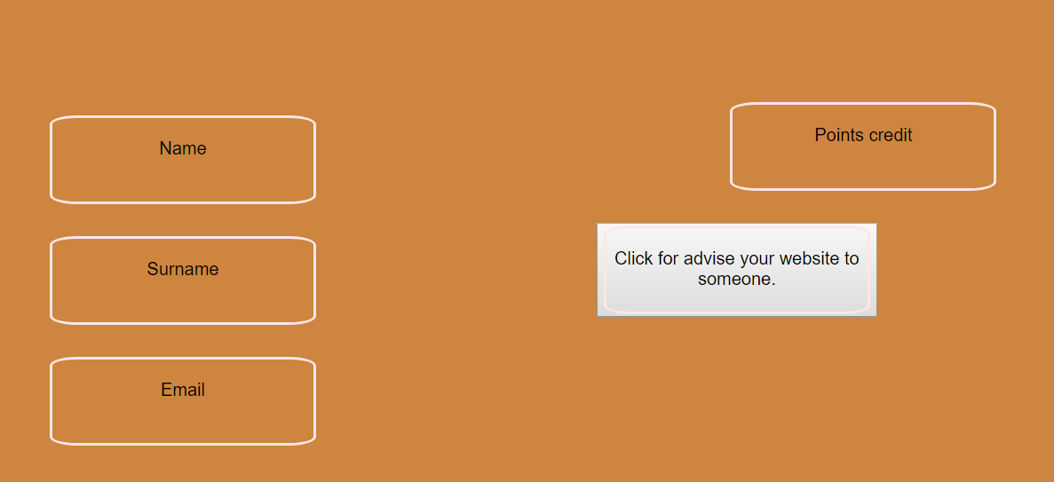

Discussion:

Argument: Aide user access information

Mohammed: Hello everyone, I will start immediately our discussion by introducing our main argument into the context which is the “Aide user access information” and we will talk about all the stuff on how to progress and develop them skills.

Karam: If you guys don’t mind, I will start as first. I shall say that the user access it means actually the main access for a digital components such as a webpage, where you have to enter your own information and have an account identifier that recognize you as a member of that web programme.

Isaaq: I absolute agree with Karam context, as also there are extra way to get interact into a web page such as a passwords, a digital scanner or face ID where only that person has got to log in.

Paul: I am not really happy with Isaaq idea about how to log in or register for an aide user access information.

Isaaq: Where do you think I went wrong, Paul?

Paul: You said that an user can get in with a digital scanner or face ID, but those area actually stuff that we do not applied into website and web programme but for different device such as laptop, smartphone and other hardware components that we normally use.

Mohammed: I am with Paul by this as I think he is right.

Karam: Yeah, he is right.

Isaaq: You are right Paul, I totally forgot the main user access and I misplaced my information. Thanks for telling me.

Paul: You are welcome, by the way talking about access information. I will introduce the last idea on it that I think is the most used by everyone. Which the voice identification, as one of the most used to identify a person.

Mohammed: And with this, that was our last point for the conversation. Thanks for joining into the conversation. See you later everyone.